BOX OFFICE REVENUE PREDICTION WITH ADVANCED ML MODELS

ABSTRACT:
The film industry faces significant financial uncertainty due to the high costs associated with movie production and marketing. Accurate prediction of box office revenue can help producers, distributors, and investors make informed decisions before release. This project focuses on predicting box office revenue using advanced machine learning models by analyzing historical movie data such as genre, budget, cast popularity, release timing, runtime, and audience sentiment. Various regression and ensemble learning techniques are applied to capture complex relationships between features and revenue outcomes. Experimental results demonstrate that advanced machine learning models significantly outperform traditional statistical approaches, providing more reliable and data-driven revenue forecasts.

INTRODUCTION

Box office performance is a critical indicator of a movie’s commercial success and directly impacts investment strategies in the entertainment industry. Traditional forecasting methods often rely on expert judgment and limited statistical models, which fail to capture the non-linear and dynamic nature of audience behavior. With the growth of data availability from movie databases, social media, and review platforms, machine learning offers powerful tools to analyze large-scale datasets and uncover hidden patterns. This project explores the application of advanced machine learning models to predict box office revenue more accurately and efficiently.

OBJECTIVE

The primary objective of this project is to develop an intelligent prediction system that estimates box office revenue before a movie’s release using historical and pre-release data. The system aims to improve prediction accuracy, reduce financial risk, and assist stakeholders in strategic decision-making through data-driven insights.

MACHINE LEARNING
Machine Learning is a system that can learn from example through self-improvement and without being explicitly coded by programmer. The breakthrough comes with the idea that a machine can singularly learn from the data (i.e., example) to produce accurate results.
Machine learning combines data with statistical tools to predict an output. This output is then used by corporate to makes actionable insights. Machine learning is closely related to data mining and Bayesian predictive modeling. The machine receives data as input, use an algorithm to formulate answers.
A typical machine learning tasks are to provide a recommendation. For those who have a Netflix account, all recommendations of movies or series are based on the user's historical data. Tech companies are using unsupervised learning to improve the user experience with personalizing recommendation.
Machine learning is also used for a variety of task like fraud detection, predictive maintenance, portfolio optimization, automatize task and so on.
MACHINE LEARNING VS. TRADITIONAL PROGRAMMING
Traditional programming differs significantly from machine learning. In traditional programming, a programmer code all the rules in consultation with an expert in the industry for which software is being developed. Each rule is based on a logical foundation; the machine will execute an output following the logical statement. When the system grows complex, more rules need to be written. It can quickly become unsustainable to maintain.

COMPUTER
DATA RULES

OUTPUT

Machine Learning

HOW DOES MACHINE LEARNING WORK?
Machine learning is the brain where all the learning takes place. The way the machine learns is similar to the human being. Humans learn from experience. The more we know, the more easily we can predict. By analogy, when we face an unknown situation, the likelihood of success is lower than the known situation. Machines are trained the same. To make an accurate prediction, the machine sees an example. When we give the machine a similar example, it can figure out the outcome. However, like a human, if its feed a previously unseen example, the machine has difficulties to predict.
The core objective of machine learning is the learning and inference. First of all, the machine learns through the discovery of patterns. This discovery is made thanks to the data. One crucial part of the data scientist is to choose carefully which data to provide to the machine. The list of attributes used to solve a problem is called a feature vector. You can think of a feature vector as a subset of data that is used to tackle a problem.
The machine uses some fancy algorithms to simplify the reality and transform this discovery into a model. Therefore, the learning stage is used to describe the data and summarize it into a model.
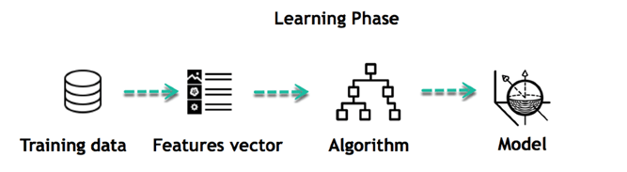
For instance, the machine is trying to understand the relationship between the wage of an individual and the likelihood to go to a fancy restaurant. It turns out the machine finds a positive relationship between wage and going to a high-end restaurant: This is the model

INFERRING
When the model is built, it is possible to test how powerful it is on never-seen-before data. The new data are transformed into a features vector, go through the model and give a prediction. This is all the beautiful part of machine learning. There is no need to update the rules or train again the model. You can use the model previously trained to make inference on new data.
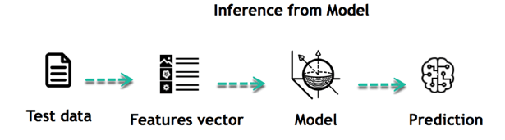
The life of Machine Learning programs is straightforward and can be summarized in the following points:
- Define a question
- Collect data
- Visualize data
- Train algorithm
- Test the Algorithm
- Collect feedback
- Refine the algorithm
- Loop 4-7 until the results are satisfying
- Use the model to make a prediction
Once the algorithm gets good at drawing the right conclusions, it applies that knowledge to new sets of data.

MACHINE LEARNING ALGORITHMS AND WHERE THEY ARE USED?

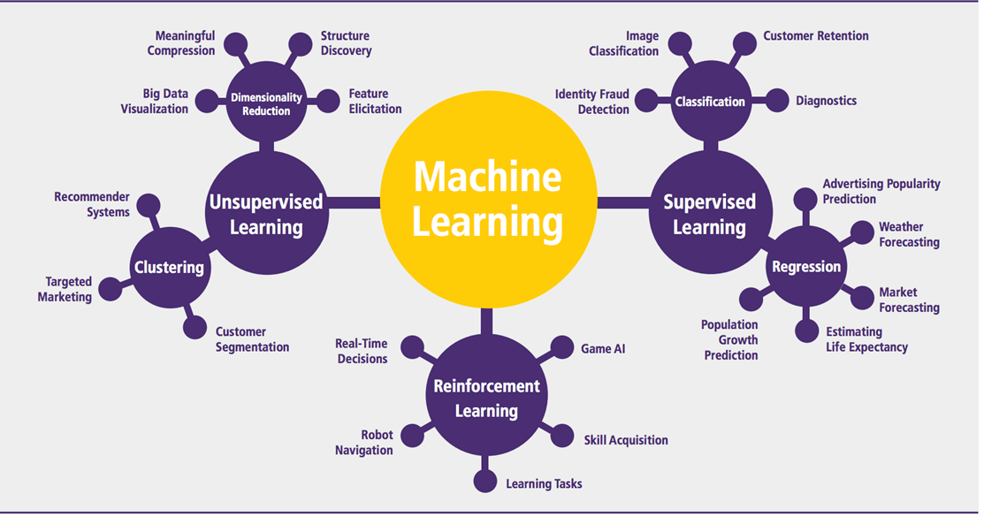
Machine learning can be grouped into two broad learning tasks: Supervised and Unsupervised. There are many other algorithms

SUPERVISED LEARNING
An algorithm uses training data and feedback from humans to learn the relationship of given inputs to a given output. For instance, a practitioner can use marketing expense and weather forecast as input data to predict the sales of cans.
You can use supervised learning when the output data is known. The algorithm will predict new data.
Supervised machine learning is a fundamental approach for machine learning and artificial intelligence. It involves training a model using labeled data, where each input comes with a corresponding correct output. The process is like a teacher guiding a student—hence the term "supervised" learning. In this article, we'll explore the key components of supervised learning, the different types of supervised machine learning algorithms used, and some practical examples of how it works.
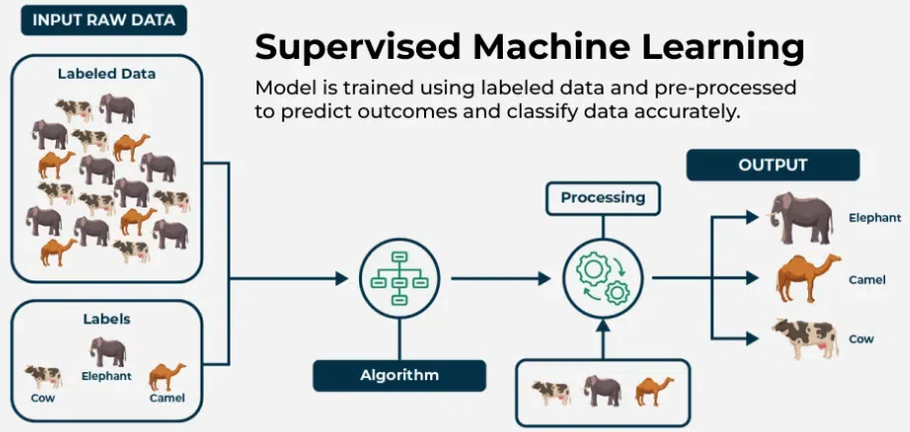
WHAT IS SUPERVISED MACHINE LEARNING?
As we explained before, supervised learning is a type of machine learning where a model is trained on labeled data—meaning each input is paired with the correct output. the model learns by comparing its predictions with the actual answers provided in the training data. Over time, it adjusts itself to minimize errors and improve accuracy. The goal of supervised learning is to make accurate predictions when given new, unseen data. For example, if a model is trained to recognize handwritten digits, it will use what it learned to correctly identify new numbers it hasn't seen before.
Supervised learning can be applied in various forms, including supervised learning classification and supervised learning regression, making it a crucial technique in the field of artificial intelligence and supervised data mining.
A fundamental concept in supervised machine learning is learning a class from examples. This involves providing the model with examples where the correct label is known, such as learning to classify images of cats and dogs by being shown labeled examples of both. The model then learns the distinguishing features of each class and applies this knowledge to classify new images.
HOW SUPERVISED MACHINE LEARNING WORKS?
Where supervised learning algorithm consists of input features and corresponding output labels. The process works through:
Training Data: The model is provided with a training dataset that includes input data (features) and corresponding output data (labels or target variables).
Learning Process: The algorithm processes the training data, learning the relationships between the input features and the output labels. This is achieved by adjusting the model's parameters to minimize the difference between its predictions and the actual labels.
After training, the model is evaluated using a test dataset to measure its accuracy and performance. Then the model's performance is optimized by adjusting parameters and using techniques like cross-validation to balance bias and variance. This ensures the model generalizes well to new, unseen data.
In summary, supervised machine learning involves training a model on labeled data to learn patterns and relationships, which it then uses to make accurate predictions on new data.
Let's learn how a supervised machine learning model is trained on a dataset to learn a mapping function between input and output, and then with learned function is used to make predictions on new data:
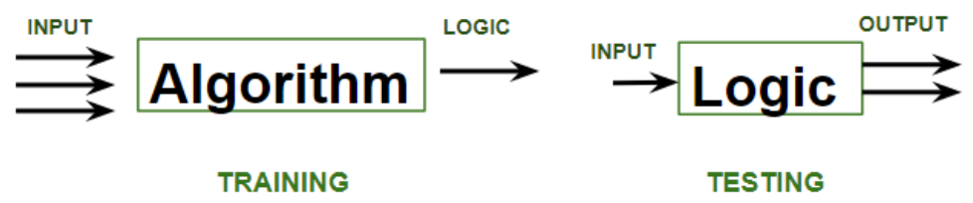
In the image above,
Training phase involves feeding the algorithm labeled data, where each data point is paired with its correct output. The algorithm learns to identify patterns and relationships between the input and output data.
Testing phase involves feeding the algorithm new, unseen data and evaluating its ability to predict the correct output based on the learned patterns.
There are two categories of supervised learning:
Algorithm Name | Description | Type
Linear regression | Finds a way to correlate each feature to the output to help predict future values. | Regression
Logistic regression | Extension of linear regression that's used for classification tasks. The output variable 3is binary (e.g., only black or white) rather than continuous (e.g., an infinite list of potential colors) | Classification
Decision tree | Highly interpretable classification or regression model that splits data-feature values into branches at decision nodes (e.g., if a feature is a color, each possible color becomes a new branch) until a final decision output is made | Regression Classification
Naive Bayes | The Bayesian method is a classification method that makes use of the Bayesian theorem. The theorem updates the prior knowledge of an event with the independent probability of each feature that can affect the event. | Regression Classification
Support vector machine | Support Vector Machine, or SVM, is typically used for the classification task. SVM algorithm finds a hyperplane that optimally divided the classes. It is best used with a non-linear solver. | Regression (not very common) Classification
Random forest | The algorithm is built upon a decision tree to improve the accuracy drastically. Random forest generates many times simple decision trees and uses the 'majority vote' method to decide on which label to return. For the classification task, the final prediction will be the one with the most vote; while for the regression task, the average prediction of all the trees is the final prediction. | Regression Classification
AdaBoost | Classification or regression technique that uses a multitude of models to come up with a decision but weighs them based on their accuracy in predicting the outcome | Regression Classification
Gradient-boosting trees | Gradient-boosting trees is a state-of-the-art classification/regression technique. It is focusing on the error committed by the previous trees and tries to correct it. | Regression Classification
- Classification task
- Regression task

CLASSIFICATION
Imagine you want to predict the gender of a customer for a commercial. You will start gathering data on the height, weight, job, salary, purchasing basket, etc. from your customer database. You know the gender of each of your customer, it can only be male or female. The objective of the classifier will be to assign a probability of being a male or a female (i.e., the label) based on the information (i.e., features you have collected). When the model learned how to recognize male or female, you can use new data to make a prediction. For instance, you just got new information from an unknown customer, and you want to know if it is a male or female. If the classifier predicts male = 70%, it means the algorithm is sure at 70% that this customer is a male, and 30% it is a female.
The label can be of two or more classes. The above example has only two classes, but if a classifier needs to predict object, it has dozens of classes (e.g., glass, table, shoes, etc. each object represents a class)

REGRESSION
When the output is a continuous value, the task is a regression. For instance, a financial analyst may need to forecast the value of a stock based on a range of feature like equity, previous stock performances, macroeconomics index. The system will be trained to estimate the price of the stocks with the lowest possible error.
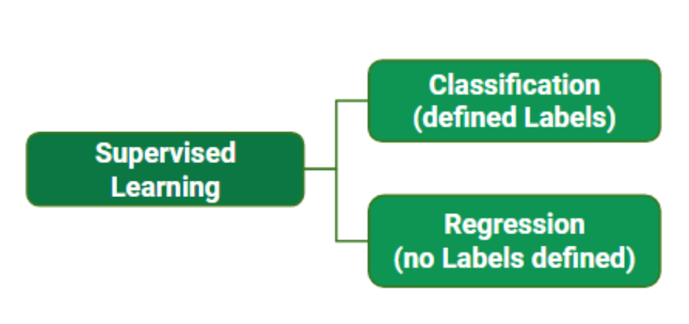
While training the model, data is usually split in the ratio of 80:20 i.e. 80% as training data and the rest as testing data. In training data, we feed input as well as output for 80% of data. The model learns from training data only.
SUPERVISED MACHINE LEARNING ALGORITHMS
Supervised learning can be further divided into several different types, each with its own unique characteristics and applications. Here are some of the most common types of supervised learning algorithms:
Linear Regression: Linear regression is a type of supervised learning regression algorithm that is used to predict a continuous output value. It is one of the simplest and most widely used algorithms in supervised learning.
Logistic Regression : Logistic regression is a type of supervised learning classification algorithm that is used to predict a binary output variable.
Decision Trees : Decision tree is a tree-like structure that is used to model decisions and their possible consequences. Each internal node in the tree represents a decision, while each leaf node represents a possible outcome.
Random Forests : Random forests again are made up of multiple decision trees that work together to make predictions. Each tree in the forest is trained on a different subset of the input features and data. The final prediction is made by aggregating the predictions of all the trees in the forest.
Support Vector Machine(SVM) : The SVM algorithm creates a hyperplane to segregate n-dimensional space into classes and identify the correct category of new data points. The extreme cases that help create the hyperplane are called support vectors, hence the name Support Vector Machine.
K-Nearest Neighbors (KNN) : KNN works by finding k training examples closest to a given input and then predicts the class or value based on the majority class or average value of these neighbors. The performance of KNN can be influenced by the choice of k and the distance metric used to measure proximity.
Gradient Boosting : Gradient Boosting combines weak learners, like decision trees, to create a strong model. It iteratively builds new models that correct errors made by previous ones.
Naive Bayes Algorithm: The Naive Bayes algorithm is a supervised machine learning algorithm based on applying Bayes' Theorem with the “naive” assumption that features are independent of each other given the class label.
TRAINING A SUPERVISED LEARNING MODEL: KEY STEPS
The goal of Supervised learning is to generalize well to unseen data. Training a model for supervised learning involves several crucial steps, each designed to prepare the model to make accurate predictions or decisions based on labeled data. Below are the key steps involved in training a model for supervised machine learning:
Data Collection and Preprocessing: Gather a labeled dataset consisting of input features and target output labels. Clean the data, handle missing values, and scale features as needed to ensure high quality for supervised learning algorithms.
Splitting the Data: Divide the data into training set (80%) and the test set (20%).
Choosing the Model: Select appropriate algorithms based on the problem type. This step is crucial for effective supervised learning in AI.
Training the Model: Feed the model input data and output labels, allowing it to learn patterns by adjusting internal parameters.
Evaluating the Model: Test the trained model on the unseen test set and assess its performance using various metrics.
Hyperparameter Tuning: Adjust settings that control the training process (e.g., learning rate) using techniques like grid search and cross-validation.
Final Model Selection and Testing: Retrain the model on the complete dataset using the best hyperparameters testing its performance on the test set to ensure readiness for deployment.
Model Deployment: Deploy the validated model to make predictions on new, unseen data.
By following these steps, supervised learning models can be effectively trained to tackle various tasks, from learning a class from examples to making predictions in real-world applications.
ADVANTAGES OF SUPERVISED LEARNING
The power of supervised learning lies in its ability to accurately predict patterns and make data-driven decisions across a variety of applications. Here are some advantages of supervised learning listed below:
Supervised learning excels in accurately predicting patterns and making data-driven decisions.
Labeled training data is crucial for enabling supervised learning models to learn input-output relationships effectively.
Supervised machine learning encompasses tasks such as supervised learning classification and supervised learning regression.
Applications include complex problems like image recognition and natural language processing.
Established evaluation metrics (accuracy, precision, recall, F1-score) are essential for assessing supervised learning model performance.
Advantages of supervised learning include creating complex models for accurate predictions on new data.
Supervised learning requires substantial labeled training data, and its effectiveness hinges on data quality and representativeness.
DISADVANTAGES OF SUPERVISED LEARNING
Despite the benefits of supervised learning methods, there are notable disadvantages of supervised learning:
Overfitting: Models can overfit training data, leading to poor performance on new data due to capturing noise in supervised machine learning.
Feature Engineering : Extracting relevant features is crucial but can be time-consuming and requires domain expertise in supervised learning applications.
Bias in Models: Bias in the training data may result in unfair predictions in supervised learning algorithms.
Dependence on Labeled Data: Supervised learning relies heavily on labeled training data, which can be costly and time-consuming to obtain, posing a challenge for supervised learning techniques.

UNSUPERVISED LEARNING
Unsupervised learning is a branch of machine learning that deals with unlabeled data. Unlike supervised learning, where the data is labeled with a specific category or outcome, unsupervised learning algorithms are tasked with finding patterns and relationships within the data without any prior knowledge of the data's meaning. Unsupervised machine learning algorithms find hidden patterns and data without any human intervention, i.e., we don't give output to our model. The training model has only input parameter values and discovers the groups or patterns on its own.
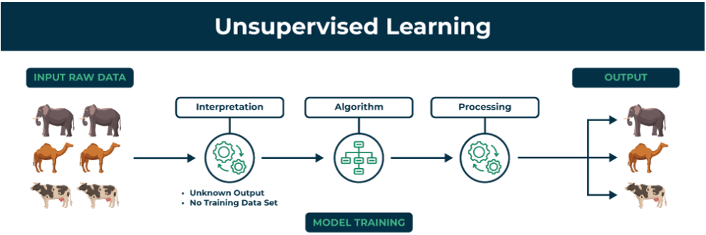
The image shows set of animals: elephants, camels, and cows that represents raw data that the unsupervised learning algorithm will process.
The "Interpretation" stage signifies that the algorithm doesn't have predefined labels or categories for the data. It needs to figure out how to group or organize the data based on inherent patterns.
Algorithm represents the core of unsupervised learning process using techniques like clustering, dimensionality reduction, or anomaly detection to identify patterns and structures in the data.
Processing stage shows the algorithm working on the data.
The output shows the results of the unsupervised learning process. In this case, the algorithm might have grouped the animals into clusters based on their species (elephants, camels, cows).
HOW DOES UNSUPERVISED LEARNING WORK?
Unsupervised learning works by analyzing unlabeled data to identify patterns and relationships. The data is not labeled with any predefined categories or outcomes, so the algorithm must find these patterns and relationships on its own. This can be a challenging task, but it can also be very rewarding, as it can reveal insights into the data that would not be apparent from a labeled dataset.
Unstructured data: May contain noisy(meaningless) data, missing values, or unknown data
Unlabeled data: Data only contains a value for input parameters, there is no targeted value(output). It is easy to collect as compared to the labeled one in the Supervised approach.
UNSUPERVISED LEARNING ALGORITHMS
There are mainly 3 types of Algorithms which are used for Unsupervised dataset.
CLUSTERING
ASSOCIATION RULE LEARNING
DIMENSIONALITY REDUCTION
1. CLUSTERING ALGORITHMS
Clustering in unsupervised machine learning is the process of grouping unlabeled data into clusters based on their similarities. The goal of clustering is to identify patterns and relationships in the data without any prior knowledge of the data's meaning.
Broadly this technique is applied to group data based on different patterns, such as similarities or differences, our machine model finds. These algorithms are used to process raw, unclassified data objects into groups. For example, in the above figure, we have not given output parameter values, so this technique will be used to group clients based on the input parameters provided by our data.
TYPE CLUSTERING ALGORITHMS:
K-means Clustering: Groups data into K clusters based on how close the points are to each other.
Hierarchical Clustering: Creates clusters by building a tree step-by-step, either merging or splitting groups.
Density-Based Clustering (DBSCAN): Finds clusters in dense areas and treats scattered points as noise.
Mean-Shift Clustering: Discovers clusters by moving points toward the most crowded areas.
Spectral Clustering: Groups data by analyzing connections between points using graphs.
2. ASSOCIATION RULE LEARNING
Association rule learning is also known as association rule mining is a common technique used to discover associations in unsupervised machine learning. This technique is a rule-based ML technique that finds out some very useful relations between parameters of a large data set. This technique is basically used for market basket analysis that helps to better understand the relationship between different products.
For e.g. shopping stores use algorithms based on this technique to find out the relationship between the sale of one product w.r.t to another's sales based on customer behavior. Like if a customer buys milk, then he may also buy bread, eggs, or butter. Once trained well, such models can be used to increase their sales by planning different offers.
TYPE OF ASSOCIATION RULE LEARNING ALGORITHMS:
Apriori Algorithm: Finds patterns by exploring frequent item combinations step-by-step.
FP-Growth Algorithm: An Efficient Alternative to Apriori. It quickly identifies frequent patterns without generating candidate sets.
Eclat Algorithm: Uses intersections of itemsets to efficiently find frequent patterns.
Efficient Tree-based Algorithms: Scales to handle large datasets by organizing data in tree structures.
3. DIMENSIONALITY REDUCTION
Dimensionality reduction is the process of reducing the number of features in a dataset while preserving as much information as possible. This technique is useful for improving the performance of machine learning algorithms and for data visualization.
Imagine a dataset of 100 features about students (height, weight, grades, etc.). To focus on key traits, you reduce it to just 2 features: height and grades, making it easier to visualize or analyze the data.
Here are some popular Dimensionality Reduction algorithms:
Principal Component Analysis (PCA): Reduces dimensions by transforming data into uncorrelated principal components.
Linear Discriminant Analysis (LDA): Reduces dimensions while maximizing class separability for classification tasks.
Non-negative Matrix Factorization (NMF): Breaks data into non-negative parts to simplify representation.
Locally Linear Embedding (LLE): Reduces dimensions while preserving the relationships between nearby points.
Isomap: Captures global data structure by preserving distances along a manifold.
CHALLENGES OF UNSUPERVISED LEARNING
Here are the key challenges of unsupervised learning:
Noisy Data: Outliers and noise can distort patterns and reduce the effectiveness of algorithms.
Assumption Dependence: Algorithms often rely on assumptions (e.g., cluster shapes), which may not match the actual data structure.
Overfitting Risk: Overfitting can occur when models capture noise instead of meaningful patterns in the data.
Limited Guidance: The absence of labels restricts the ability to guide the algorithm toward specific outcomes.
Cluster Interpretability: Results, such as clusters, may lack clear meaning or alignment with real-world categories.
Sensitivity to Parameters: Many algorithms require careful tuning of hyperparameters, such as the number of clusters in k-means.
Lack of Ground Truth: Unsupervised learning lacks labeled data, making it difficult to evaluate the accuracy of results.
APPLICATIONS OF UNSUPERVISED LEARNING
Unsupervised learning has diverse applications across industries and domains. Key applications include:
Customer Segmentation: Algorithms cluster customers based on purchasing behavior or demographics, enabling targeted marketing strategies.
Anomaly Detection: Identifies unusual patterns in data, aiding fraud detection, cybersecurity, and equipment failure prevention.
Recommendation Systems: Suggests products, movies, or music by analyzing user behavior and preferences.
Image and Text Clustering: Groups similar images or documents for tasks like organization, classification, or content recommendation.
Social Network Analysis: Detects communities or trends in user interactions on social media platforms.
Astronomy and Climate Science: Classifies galaxies or groups weather patterns to support scientific research
Algorithm | Description | Type
K-means clustering | Puts data into some groups (k) that each contains data with similar characteristics (as determined by the model, not in advance by humans) | Clustering
Gaussian mixture model | A generalization of k-means clustering that provides more flexibility in the size and shape of groups (clusters | Clustering
Hierarchical clustering | Splits clusters along a hierarchical tree to form a classification system.  Can be used for Cluster loyalty-card customer | Clustering
Recommender system | Help to define the relevant data for making a recommendation. | Clustering
PCA/T-SNE | Mostly used to decrease the dimensionality of the data. The algorithms reduce the number of features to 3 or 4 vectors with the highest variances. | Dimension Reduction

APPLICATION OF MACHINE LEARNING
Augmentation:
- Machine learning, which assists humans with their day-to-day tasks, personally or commercially without having complete control of the output. Such machine learning is used in different ways such as Virtual Assistant, Data analysis, software solutions. The primary user is to reduce errors due to human bias.
Automation:
- Machine learning, which works entirely autonomously in any field without the need for any human intervention. For example, robots performing the essential process steps in manufacturing plants.
Finance Industry
- Machine learning is growing in popularity in the finance industry. Banks are mainly using ML to find patterns inside the data but also to prevent fraud.
Government organization
- The government makes use of ML to manage public safety and utilities. Take the example of China with the massive face recognition. The government uses Artificial intelligence to prevent jaywalker.
Healthcare industry
- Healthcare was one of the first industry to use machine learning with image detection.
Marketing
- Broad use of AI is done in marketing thanks to abundant access to data. Before the age of mass data, researchers develop advanced mathematical tools like Bayesian analysis to estimate the value of a customer. With the boom of data, marketing department relies on AI to optimize the customer relationship and marketing campaign.
Example of application of Machine Learning in Supply Chain
Machine learning gives terrific results for visual pattern recognition, opening up many potential applications in physical inspection and maintenance across the entire supply chain network.
Unsupervised learning can quickly search for comparable patterns in the diverse dataset. In turn, the machine can perform quality inspection throughout the logistics hub, shipment with damage and wear.
For instance, IBM's Watson platform can determine shipping container damage. Watson combines visual and systems-based data to track, report and make recommendations in real-time.
In past year stock manager relies extensively on the primary method to evaluate and forecast the inventory. When combining big data and machine learning, better forecasting techniques have been implemented (an improvement of 20 to 30 % over traditional forecasting tools). In term of sales, it means an increase of 2 to 3 % due to the potential reduction in inventory costs.
Example of Machine Learning Google Car
For example, everybody knows the Google car. The car is full of lasers on the roof which are telling it where it is regarding the surrounding area. It has radar in the front, which is informing the car of the speed and motion of all the cars around it. It uses all of that data to figure out not only how to drive the car but also to figure out and predict what potential drivers around the car are going to do. What's impressive is that the car is processing almost a gigabyte a second of data.
REINFORCEMENT LEARNING
Reinforcement learning is a subfield of machine learning in which systems are trained by receiving virtual "rewards" or "punishments," essentially learning by trial and error. Google's DeepMind has used reinforcement learning to beat a human champion in the Go games. Reinforcement learning is also used in video games to improve the gaming experience by providing smarter bot.
One of the most famous algorithms are:
- Q-learning
- Deep Q network
- State-Action-Reward-State-Action (SARSA)
- Deep Deterministic Policy Gradient (DDPG)
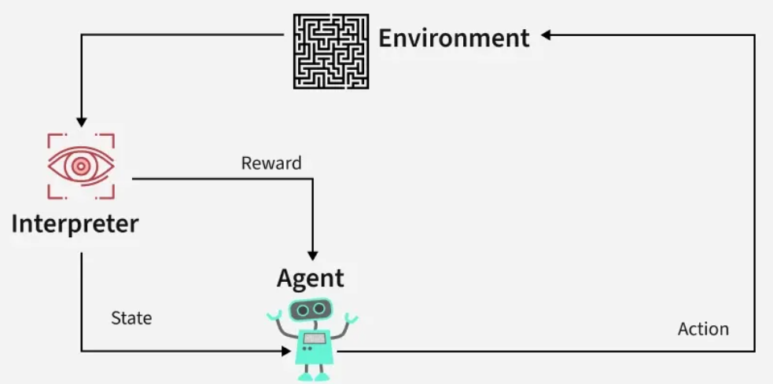
Reinforcement Learning revolves around the idea that an agent (the learner or decision-maker) interacts with an environment to achieve a goal. The agent performs actions and receives feedback to optimize its decision-making over time.
Agent: The decision-maker that performs actions.
Environment: The world or system in which the agent operates.
State: The situation or condition the agent is currently in.
Action: The possible moves or decisions the agent can make.
Reward: The feedback or result from the environment based on the agent’s action.
HOW REINFORCEMENT LEARNING WORKS?
The RL process involves an agent performing actions in an environment, receiving rewards or penalties based on those actions, and adjusting its behavior accordingly. This loop helps the agent improve its decision-making over time to maximize the cumulative reward.
Here’s a breakdown of RL components:
Policy: A strategy that the agent uses to determine the next action based on the current state.
Reward Function: A function that provides feedback on the actions taken, guiding the agent towards its goal.
Value Function: Estimates the future cumulative rewards the agent will receive from a given state.
Model of the Environment: A representation of the environment that predicts future states and rewards, aiding in planning.
Reinforcement Learning Example: Navigating a Maze
Imagine a robot navigating a maze to reach a diamond while avoiding fire hazards. The goal is to find the optimal path with the least number of hazards while maximizing the reward:
Each time the robot moves correctly, it receives a reward.
If the robot takes the wrong path, it loses points.
The robot learns by exploring different paths in the maze. By trying various moves, it evaluates the rewards and penalties for each path. Over time, the robot determines the best route by selecting the actions that lead to the highest cumulative reward.
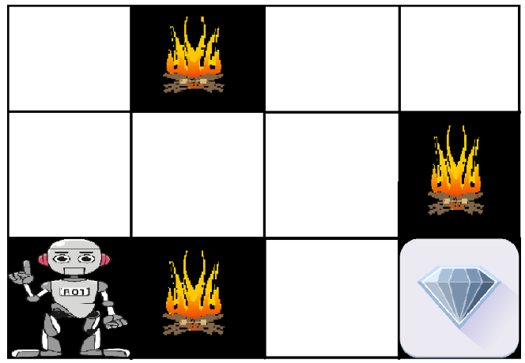
The robot's learning process can be summarized as follows:
Exploration: The robot starts by exploring all possible paths in the maze, taking different actions at each step (e.g., move left, right, up, or down).
Feedback: After each move, the robot receives feedback from the environment:
A positive reward for moving closer to the diamond.
A penalty for moving into a fire hazard.
Adjusting Behavior: Based on this feedback, the robot adjusts its behavior to maximize the cumulative reward, favoring paths that avoid hazards and bring it closer to the diamond.
Optimal Path: Eventually, the robot discovers the optimal path with the least number of hazards and the highest reward by selecting the right actions based on past experiences.
TYPES OF REINFORCEMENTS IN RL
1. Positive Reinforcement
Positive Reinforcement is defined as when an event, occurs due to a particular behavior, increases the strength and the frequency of the behavior. In other words, it has a positive effect on behavior.
Advantages: Maximizes performance, helps sustain change over time.
Disadvantages: Overuse can lead to excess states that may reduce effectiveness.
2. Negative Reinforcement
Negative Reinforcement is defined as strengthening of behavior because a negative condition is stopped or avoided.
Advantages: Increases behavior frequency, ensures a minimum performance standard.
Disadvantages: It may only encourage just enough action to avoid penalties.
Application of Reinforcement Learning
Robotics: RL is used to automate tasks in structured environments such as manufacturing, where robots learn to optimize movements and improve efficiency.
Game Playing: Advanced RL algorithms have been used to develop strategies for complex games like chess, Go, and video games, outperforming human players in many instances.
Industrial Control: RL helps in real-time adjustments and optimization of industrial operations, such as refining processes in the oil and gas industry.
Personalized Training Systems: RL enables the customization of instructional content based on an individual's learning patterns, improving engagement and effectiveness.
ADVANTAGES OF REINFORCEMENT LEARNING
Solving Complex Problems: RL is capable of solving highly complex problems that cannot be addressed by conventional techniques.
Error Correction: The model continuously learns from its environment and can correct errors that occur during the training process.
Direct Interaction with the Environment: RL agents learn from real-time interactions with their environment, allowing adaptive learning.
Handling Non-Deterministic Environments: RL is effective in environments where outcomes are uncertain or change over time, making it highly useful for real-world applications.
DISADVANTAGES OF REINFORCEMENT LEARNING
Not Suitable for Simple Problems: RL is often an overkill for straightforward tasks where simpler algorithms would be more efficient.
High Computational Requirements: Training RL models requires a significant amount of data and computational power, making it resource-intensive.
Dependency on Reward Function: The effectiveness of RL depends heavily on the design of the reward function. Poorly designed rewards can lead to suboptimal or undesired behaviors.
Difficulty in Debugging and Interpretation: Understanding why an RL agent makes certain decisions can be challenging, making debugging and troubleshooting complex
Reinforcement Learning is a powerful technique for decision-making and optimization in dynamic environments. However, the complexity of RL necessitates careful design of reward functions and substantial computational resources. By understanding its principles and applications, RL can be leveraged to solve intricate real-world problems and drive advancements across various industries.
DEEP LEARNING
Deep learning is a computer software that mimics the network of neurons in a brain. It is a subset of machine learning and is called deep learning because it makes use of deep neural networks. The machine uses different layers to learn from the data. The depth of the model is represented by the number of layers in the model. Deep learning is the new state of the art in term of AI. In deep learning, the learning phase is done through a neural network.
HOW DEEP LEARNING WORKS?
Neural network consists of layers of interconnected nodes or neurons that collaborate to process input data. In a fully connected deep neural network data flows through multiple layers where each neuron performs nonlinear transformations, allowing the model to learn intricate representations of the data.
In a deep neural network the input layer receives data which passes through hidden layers that transform the data using nonlinear functions. The final output layer generates the model’s prediction.
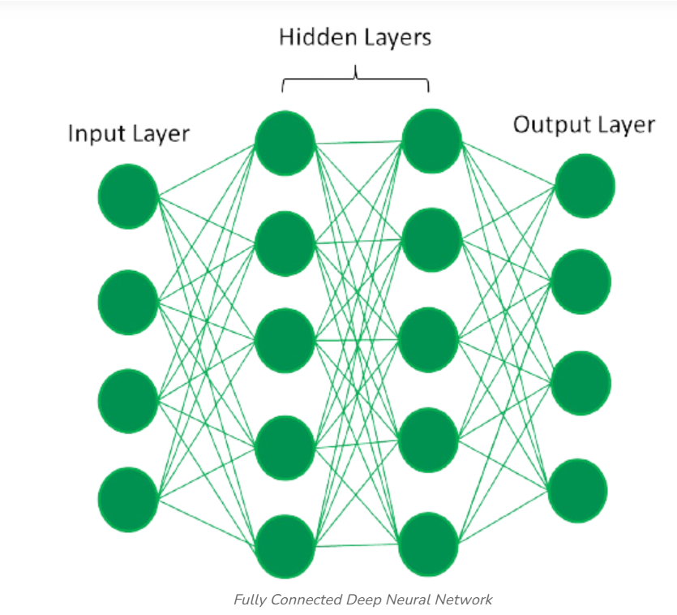
EVOLUTION OF NEURAL ARCHITECTURES
The journey of deep learning began with the perceptron, a single-layer neural network introduced in the 1950s. While innovative, perceptrons could only solve linearly separable problems hence failing at more complex tasks like the XOR problem.

This limitation led to the development of Multi-Layer Perceptrons (MLPs). It introduced hidden layers and non-linear activation functions. MLPs trained using backpropagation could model complex, non-linear relationships marking a significant leap in neural network capabilities. This evolution from perceptrons to MLPs laid the groundwork for advanced architectures like CNNs and RNNs, showcasing the power of layered structures in solving real-world problems.
TYPES OF NEURAL NETWORKS
Feedforward neural networks (FNNs) are the simplest type of ANN, where data flows in one direction from input to output. It is used for basic tasks like classification.
Convolutional Neural Networks (CNNs) are specialized for processing grid-like data, such as images. CNNs use convolutional layers to detect spatial hierarchies, making them ideal for computer vision tasks.
Recurrent Neural Networks (RNNs) are able to process sequential data, such as time series and natural language. RNNs have loops to retain information over time, enabling applications like language modeling and speech recognition. Variants like LSTMs and GRUs address vanishing gradient issues.
Generative Adversarial Networks (GANs) consist of two networks—a generator and a discriminator—that compete to create realistic data. GANs are widely used for image generation, style transfer and data augmentation.
Autoencoders are unsupervised networks that learn efficient data encodings. They compress input data into a latent representation and reconstruct it, useful for dimensionality reduction and anomaly detection.
Transformer Networks has revolutionized NLP with self-attention mechanisms. Transformers excel at tasks like translation, text generation and sentiment analysis, powering models like GPT and BERT.
DEEP LEARNING APPLICATIONS
1. Computer vision
In computer vision, deep learning models enable machines to identify and understand visual data. Some of the main applications of deep learning in computer vision include:
Object detection and recognition: Deep learning models are used to identify and locate objects within images and videos, making it possible for machines to perform tasks such as self-driving cars, surveillance and robotics.
Image classification: Deep learning models can be used to classify images into categories such as animals, plants and buildings. This is used in applications such as medical imaging, quality control and image retrieval.
Image segmentation: Deep learning models can be used for image segmentation into different regions, making it possible to identify specific features within images.
2. Natural language processing (NLP)
In NLP, deep learning model enable machines to understand and generate human language. Some of the main applications of deep learning in NLP include:
Automatic Text Generation: Deep learning model can learn the corpus of text and new text like summaries, essays can be automatically generated using these trained models.
Language translation: Deep learning models can translate text from one language to another, making it possible to communicate with people from different linguistic backgrounds.
Sentiment analysis: Deep learning models can analyze the sentiment of a piece of text, making it possible to determine whether the text is positive, negative or neutral.
Speech recognition: Deep learning models can recognize and transcribe spoken words, making it possible to perform tasks such as speech-to-text conversion, voice search and voice-controlled devices.
3. Reinforcement learning
In reinforcement learning, deep learning works as training agents to take action in an environment to maximize a reward. Some of the main applications of deep learning in reinforcement learning include:
Game playing: Deep reinforcement learning models have been able to beat human experts at games such as Go, Chess and Atari.
Robotics: Deep reinforcement learning models can be used to train robots to perform complex tasks such as grasping objects, navigation and manipulation.
Control systems: Deep reinforcement learning models can be used to control complex systems such as power grids, traffic management and supply chain optimization.
Advantages of Deep Learning
High accuracy: Deep Learning algorithms can achieve state-of-the-art performance in various tasks such as image recognition and natural language processing.
Automated feature engineering: Deep Learning algorithms can automatically discover and learn relevant features from data without the need for manual feature engineering.
Scalability: Deep Learning models can scale to handle large and complex datasets and can learn from massive amounts of data.
Flexibility: Deep Learning models can be applied to a wide range of tasks and can handle various types of data such as images, text and speech.
Continual improvement: Deep Learning models can continually improve their performance as more data becomes available.
Disadvantages of Deep Learning
Deep learning has made significant advancements in various fields but there are still some challenges that need to be addressed. Here are some of the main challenges in deep learning:
Data availability: It requires large amounts of data to learn from. For using deep learning it's a big concern to gather as much data for training.
Computational Resources: For training the deep learning model, it is computationally expensive because it requires specialized hardware like GPUs and TPUs.
Time-consuming: While working on sequential data depending on the computational resource it can take very large even in days or months.
Interpretability: Deep learning models are complex, it works like a black box. It is very difficult to interpret the result.
Overfitting: when the model is trained again and again it becomes too specialized for the training data leading to overfitting and poor performance on new data.
As we continue to push the boundaries of computational power and dataset sizes, the potential applications of deep learning are limitless. Deep Learning promises to reshape our future where machines can learn, adapt and solve complex problems at a scale and speed previously unimaginable.
APPLICATIONS/ EXAMPLES OF DEEP LEARNING APPLICATIONS
AI in Finance: The financial technology sector has already started using AI to save time, reduce costs, and add value. Deep learning is changing the lending industry by using more robust credit scoring. Credit decision-makers can use AI for robust credit lending applications to achieve faster, more accurate risk assessment, using machine intelligence to factor in the character and capacity of applicants.
Underwrite is a Fintech company providing an AI solution for credit makers company. underwrite.ai uses AI to detect which applicant is more likely to pay back a loan. Their approach radically outperforms traditional methods.
AI in HR: Under Armour, a sportswear company revolutionizes hiring and modernizes the candidate experience with the help of AI. In fact, Under Armour Reduces hiring time for its retail stores by 35%. Under Armour faced a growing popularity interest back in 2012. They had, on average, 30000 resumes a month. Reading all of those applications and begin to start the screening and interview process was taking too long. The lengthy process to get people hired and on-boarded impacted Under Armour's ability to have their retail stores fully staffed, ramped and ready to operate.
At that time, Under Armour had all of the 'must have' HR technology in place such as transactional solutions for sourcing, applying, tracking and onboarding but those tools weren't useful enough. Under armour choose HireVue, an AI provider for HR solution, for both on-demand and live interviews. The results were bluffing; they managed to decrease by 35% the time to fill. In return, the hired higher quality staffs.
AI in Marketing: AI is a valuable tool for customer service management and personalization challenges. Improved speech recognition in call-center management and call routing as a result of the application of AI techniques allows a more seamless experience for customers.
For example, deep-learning analysis of audio allows systems to assess a customer's emotional tone. If the customer is responding poorly to the AI chatbot, the system can be rerouted the conversation to real, human operators that take over the issue.
Apart from the three examples above, AI is widely used in other sectors/industries.
Artificial Intelligence
ML
Machine Learning
Deep Learning

 | Machine Learning | Deep Learning
Data Dependencies | Excellent performances on a small/medium dataset | Excellent performance on a big dataset
Hardware dependencies | Work on a low-end machine. | Requires powerful machine, preferably with GPU: DL performs a significant amount of matrix multiplication
Feature engineering | Need to understand the features that represent the data | No need to understand the best feature that represents the data
Execution time | From few minutes to hours | Up to weeks. Neural Network needs to compute a significant number of weights
Interpretability | Some algorithms are easy to interpret (logistic, decision tree), some are almost impossible (SVM, XGBoost) | Difficult to impossible

DIFFERENCE BETWEEN MACHINE LEARNING AND DEEP LEARNING

WHEN TO USE ML OR DL?
In the table below, we summarize the difference between machine learning and deep learning.
 | Machine learning | Deep learning
Training dataset | Small | Large
Choose features | Yes | No
Number of algorithms | Many | Few
Training time | Short | Long
With machine learning, you need fewer data to train the algorithm than deep learning. Deep learning requires an extensive and diverse set of data to identify the underlying structure. Besides, machine learning provides a faster-trained model. Most advanced deep learning architecture can take days to a week to train. The advantage of deep learning over machine learning is it is highly accurate. You do not need to understand what features are the best representation of the data; the neural network learned how to select critical features. In machine learning, you need to choose for yourself what features to include in the model.
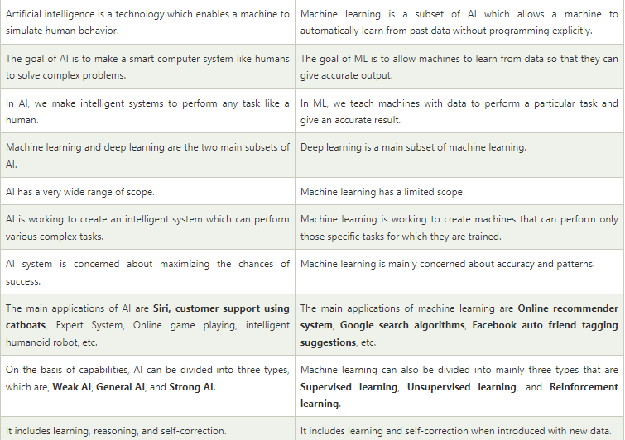
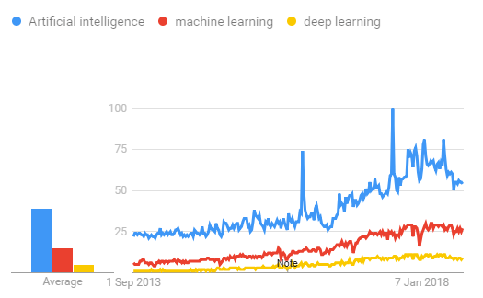

TENSORFLOW
the most famous deep learning library in the world is Google's TensorFlow. Google product uses machine learning in all of its products to improve the search engine, translation, image captioning or recommendations.
To give a concrete example, Google users can experience a faster and more refined the search with AI. If the user types a keyword a the search bar, Google provides a recommendation about what could be the next word.
Google wants to use machine learning to take advantage of their massive datasets to give users the best experience. Three different groups use machine learning:
- Researchers
- Data scientists
- Programmers.
They can all use the same toolset to collaborate with each other and improve their efficiency.
Google does not just have any data; they have the world's most massive computer, so TensorFlow was built to scale. TensorFlow is a library developed by the Google Brain Team to accelerate machine learning and deep neural network research.
It was built to run on multiple CPUs or GPUs and even mobile operating systems, and it has several wrappers in several languages like Python, C++ or Java.
In this tutorial, you will learn
TENSORFLOW ARCHITECTURE
Tensor flow architecture works in three parts:
- Pre processing the data
- Build the model
- Train and estimate the model
It is called Tensor flow because it takes input as a multi-dimensional array, also known as tensors. You can construct a sort of flowchart of operations (called a Graph) that you want to perform on that input. The input goes in at one end, and then it flows through this system of multiple operations and comes out the other end as output.
This is why it is called TensorFlow because the tensor goes in it flows through a list of operations, and then it comes out the other side.
Where can Tensor flow run?
TensorFlow can hardware, and software requirements can be classified into
Development Phase: This is when you train the mode. Training is usually done on your Desktop or laptop.
Run Phase or Inference Phase: Once training is done Tensorflow can be run on many different platforms. You can run it on
- Desktop running Windows, macOS or Linux
- Cloud as a web service
- Mobile devices like iOS and Android
You can train it on multiple machines then you can run it on a different machine, once you have the trained model.
The model can be trained and used on GPUs as well as CPUs. GPUs were initially designed for video games. In late 2010, Stanford researchers found that GPU was also very good at matrix operations and algebra so that it makes them very fast for doing these kinds of calculations. Deep learning relies on a lot of matrix multiplication. TensorFlow is very fast at computing the matrix multiplication because it is written in C++. Although it is implemented in C++, TensorFlow can be accessed and controlled by other languages mainly, Python.
Finally, a significant feature of Tensor Flow is the Tensor Board. The Tensor Board enables to monitor graphically and visually what TensorFlow is doing.
List of Prominent Algorithms supported by TensorFlow
- Linear regression: tf. estimator .Linear Regressor
- Classification :tf. Estimator .Linear Classifier
- Deep learning classification: tf. estimator. DNN Classifier
- Booster tree regression: tf.estimator.BoostedTreesRegressor
Boosted tree classification: tf.estimator.BoostedTreesClassifier
LITERATURE SURVEY

S.NO | TITLE / SOURCE | AUTHORS / YEAR | TECHNIQUES USED | KEY CONTRIBUTIONS / FINDINGS | LIMITATIONS / NOTES
1 | Long–Range Movie Box Office Prediction Based on Machine Learning | Xu (2024) | Random Forest, Back Propagation NN, Linear Regression | Compares multiple ML models (RF, neural networks) using movie metadata to forecast long-range revenue with up to ~73% accuracy. | Focuses on traditional ML; limited use of deep models.
2 | Predicting Box-Office Markets with Machine Learning Methods | Li & Liu (2022) | SVM, time-series ML models | Empirical comparison of eight ML methods for national box office forecasting; SVM with GDP performed best. | Relies on economic factors; may not capture social/marketing signals.
3 | A Multimodal Machine Learning Framework for Box Office Prediction | Li et al. (2025) | CNN (trailer sentiment), Random Forest, ensemble | Integrates trailer sentiment (image/video analysis) with ensemble RF predictions, achieving robust forecasting performance. | Requires multimodal data (trailers) and complex preprocessing.
4 | Predicting Movie Box Office Based on Machine Learning & Deep Models | Zheng (2024) | Random Forest, XGBoost, BiLSTM, RNN | Uses traditional and deep learning methods on TMDB data, demonstrating deep models enhance prediction accuracy. | Requires large, labeled datasets for deep training.
5 | Forecasting Box Office Revenue Using Neural Networks & Emotional Mining | Zhang et al. (2024) | Neural networks + sentiment mining | Combines neural nets with emotional analysis of viewer comments to improve box office prediction accuracy. | Needs extensive sentiment data preprocessing.
6 | Box Office Forecasting Using SNS Data | Kim, Hong & Kang (2015) | Machine learning with social network indicators | Uses SNS (social network service) data with ML regression to forecast box office before and after release. | Older study; still foundational for social data use.
7 | IMDB Box Office Prediction Using ML Algorithms | Gore et al. (2022) | ML models on IMDB dataset | Applies ML techniques to movie datasets (e.g., budget, ratings) for revenue prediction, highlighting feature impact. | Traditional ML; limited modern deep techniques.
8 | Research on Movie Box Office Prediction Model | Yan (2025) | Random Forest, XGBoost, Cross-validation | Evaluates multiple models (RF, XGBoost) with feature importance analysis identifying key predictors like budget and votes. | Does not include multimodal or sentiment features.
9 | Copycat vs. Original: Multimodal Pretraining for Box Office | Qin, Kim & Li (2025) | Deep multimodal neural net | Sophisticated multimodal pretraining combining poster imagery and textual features for enhanced prediction with reduced error. | Cutting-edge research; complex model architecture required.
10 | Movie Popularity Prediction Using Supervised ML | Zhang & Bai (2023) | Random Forest, Naïve Bayes, SVR | Uses supervised learning to predict movie popularity, which correlates with revenue potential. | Focuses on popularity as proxy for revenue; needs direct revenue linkage.

EXISTING SYSTEM:

Existing box office prediction systems are mainly based on traditional statistical techniques such as linear regression and econometric models. These systems typically consider a limited number of factors like budget and release date and often ignore complex feature interactions. In many cases, predictions rely on manual analysis and expert intuition, making them subjective and less scalable.

DISADVANTAGES OF EXISTING SYSTEM

- Limited ability to model non-linear relationships

- Low prediction accuracy for diverse movie genres

- Inability to handle large and high-dimensional datasets

- High dependency on human judgment

- Poor adaptability to changing audience trends

PROPOSED SYSTEM

The proposed system leverages advanced machine learning models such as Random Forest, Gradient Boosting, XGBoost, and Deep Neural Networks to predict box office revenue. The system integrates multiple data sources including historical movie performance, production details, and audience sentiment indicators. Feature engineering and data preprocessing techniques are applied to enhance model performance. By learning complex patterns from data, the system provides more accurate and robust revenue predictions compared to traditional approaches.

ADVANTAGES OF PROPOSED SYSTEM

- High prediction accuracy

- Ability to capture non-linear and complex feature interactions

- Scalability for large datasets

- Reduced human bias

- Adaptability to new trends and data

SYSTEM ANALYSIS
SYSTEM ARCHITECTURE:
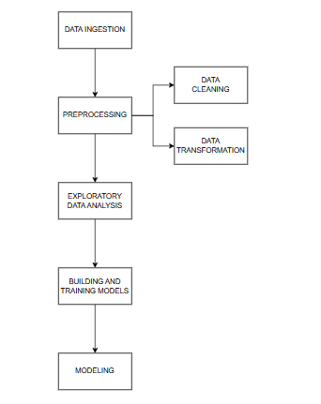
SYSTEM REQUIREMENTS

FUNCTIONAL REQUIREMENTS
Movie dataset collection and storage

Data preprocessing and feature extraction

Machine learning model training and testing

Revenue prediction module

Performance evaluation using metrics such as RMSE and R²

User interface for input and visualization of results

NON-FUNCTIONAL REQUIREMENTS

High system accuracy and reliability

Scalability to handle large datasets

Fast model inference time

Data security and integrity

Maintainability and extensibility

Usability with minimal user intervention

HARDWARE AND SOFTWARE REQUIREMENTS:
HARDWARE:
OS | Windows 7, 8 and 10 (32 and 64 bit)
RAM | 4GB
SOFTWARE:
Programming Language | Python
Tools | Anaconda Navigator
Database | Dataset
SYSTEM DESIGN
UML DIAGRAMS
The system “Protecting Women from Safety Threats Using Machine Learning” is designed using UML (Unified Modeling Language), which helps in specifying, visualizing, constructing, and documenting the architecture and behavior of a machine-learning–based safety system. UML provides a standardized way to understand the interactions between women users, the ML engine, the alerting system, and other connected components.

UML diagrams give a clear representation of:

- Actors (users, authorities, ML model)

- Safety event flow

- Alert processes

- Prediction workflow

- Database interactions

- Geolocation tracking system

- Emergency communication components

- Reusable software modules

UML integrates concepts from data modeling, object modeling, component modeling, and workflow modeling, making it suitable for designing safety-critical, distributed ML systems. This is important for a system that predicts threats, sends alerts, and processes real-time data.

The UML diagrams help visualize the entire life cycle of the safety system—from threat detection, classification, and prediction to automated emergency responses.

SEQUENCE DIAGRAM

A Sequence Diagram represents the sequence of interactions between the woman user, the mobile application, the machine learning model, the alert system, and the emergency contacts.

In the “Protecting Women from Safety Threats Using Machine Learning” project, the sequence diagram explains how:

- A woman user sends input (voice, text, sensor signal, SOS button).

- The mobile app forwards data to the ML threat-detection module.

- The ML model classifies the input as safe or unsafe.

- If unsafe, the system triggers:

- location tracking

- SMS alert to emergency contacts

- notification to authorities

- loud siren activation

- The system updates the database with logs.

- A confirmation message is sent back to the user.

- The purpose of the sequence diagram is to show how data flows step-by-step in a safety emergency.

ACTIVITY DIAGRAM

Activity diagrams describe the workflow of machine-learning-based threat detection and emergency response.

For this project, the activity diagram represents:

User opens the safety app

Sensor/voice/location data is collected

ML model predicts “Safe / Unsafe”
The diagram visually explains the complete flow of safety detection, from input collection to emergency action.

USE CASE DIAGRAM

The Use Case Diagram describes how different users and systems interact with the women safety threat protection application. The primary actor is the woman or end user who accesses the app to ensure her safety. Other actors include emergency contacts, police authorities, the application administrator, and the machine learning system itself. The use case diagram visualizes the major functionalities such as user registration, enabling safety mode, sharing live location, detecting threats using machine learning algorithms, and sending automatic emergency alerts when danger is predicted.

This diagram shows the interactions between the user and the system from a functional perspective. When the user enables the safety mode, the app collects various sensor data such as GPS, audio, and movement patterns. The machine learning module analyzes this data to determine risk levels. If the predicted threat is high, the system automatically sends alerts to the police and the user’s emergency contacts. The use case diagram helps in understanding the external behavior of the system without showing its internal workings.
CLASS DIAGRAM

The Class Diagram gives a structural view of the system by representing different classes, their attributes, and their interactions. In this system, the major classes include the User class, SensorManager class, DataPreprocessor class, ThreatDetectionModel class, AlertSystem class, EvidenceRecorder class, and Admin class. Each class is responsible for specific functionalities.

The User class handles user information, emergency contacts, and profile updates. The SensorManager collects data from GPS, microphone, and motion sensors. The DataPreprocessor prepares the raw data for machine learning analysis. The ThreatDetectionModel class represents the ML algorithm that predicts security threats. The AlertSystem class manages notifications, alerts, and communication with authorities. The EvidenceRecorder class captures and uploads audio/video evidence during emergencies. The Admin class manages datasets, monitors system performance, and retrains the ML model when required. This diagram explains how the system’s components are organized and interconnected to ensure smooth functioning.
USECASE DIAGRAM
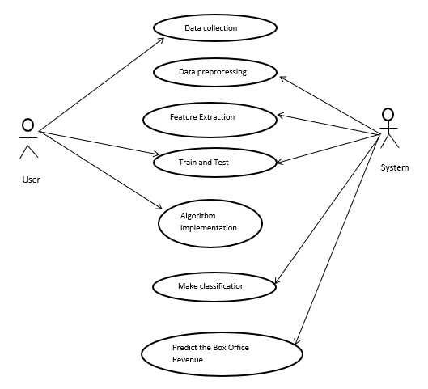
SEQUENCE DIAGRAM

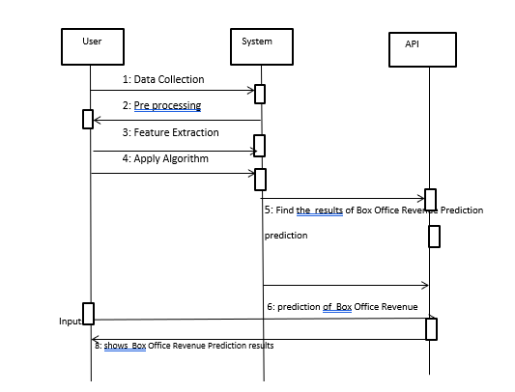

ACTIVITY DIAGRAM
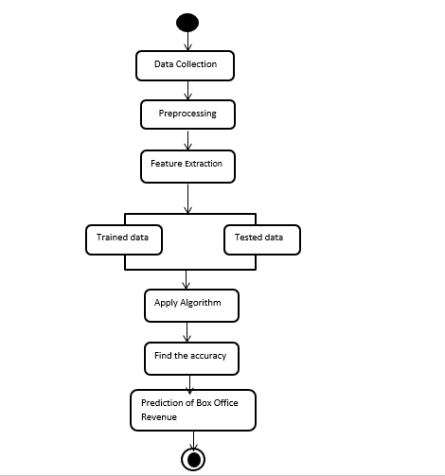

COLLABORATION DIAGRAM
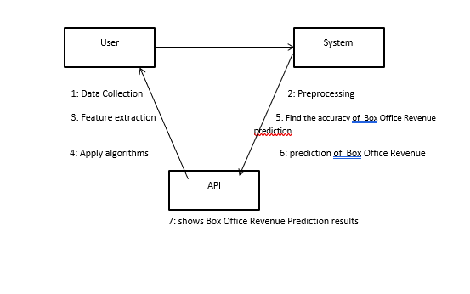
CLASS DIAGRAM
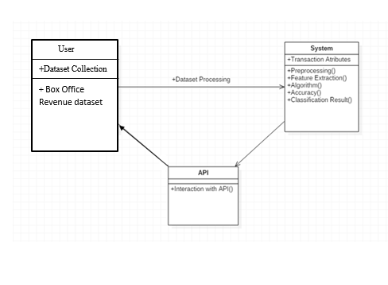
DATA FLOW DIAGRAMS

The abbreviation for Information Stream Outline is DFD. DFD deals with the information flow of a framework or an interaction. Additionally, it provides information on the data sources, outcomes, and actual interactions for each factor. There are no circles, choice criteria, or control streams in DFD. A flowchart can make sense of explicit tasks reliant on the type of data.
It is a graphical tool that makes communicating with clients, supervisors, and other faculty members easier. It is useful for dissecting both the current and the suggested structure.
It provides a summary of the framework procedures for what information there is.
What adjustments are made, what data is archived, what outputs are made, and so on.
There are various ways to address the Information Stream Outline. There are organised investigation exhibiting gadgets at the DFD. Information Stream graphs are well known because they let us visualise the important steps and information involved in programming framework activities.
Four sections make up the information stream graph:

Process Due to dealing capability, a framework's ability to produce change is affected. Images of a conversation may be round, oval, square, or rectangular with rounded corners. The cycle is given a brief name that communicates its essence in a single word or statement.
Information Stream Information stream depicts the data moving between various pieces of the frameworks. The bolt image is the image of information stream. An engaging name ought to be given to the stream to decide the data which is being moved. Information stream additionally addresses material alongside data that is being moved. Material movements are displayed in frameworks that are not simply useful. A given stream ought to just exchange a solitary kind of data. The course of stream is addressed by the bolt which can likewise be bi-directional.
Distribution center The information is put away in the stockroom for sometime in the future. Two flat lines address the image of the store. The distribution center is essentially not confined to being an information record rather it very well may be in any way similar to an envelope with reports, an optical circle, a file organizer. The information distribution center can be seen autonomous of its execution. At the point when the information stream from the stockroom it is considered as information perusing and when information streams to the distribution center it is called information passage or information refreshing.
Eliminator The Eliminator is an outer substance that stands beyond the framework and speaks with the framework. It very well may be, for instance, associations like banks, gatherings like clients or various divisions of a similar association, which isn't a piece of the model framework and is an outside element. Displayed frameworks additionally speak with eliminator.
Level 0
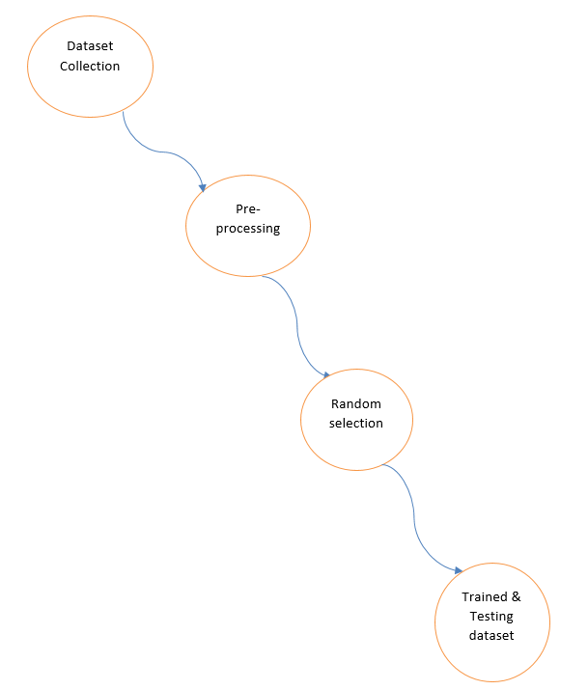
Level 1
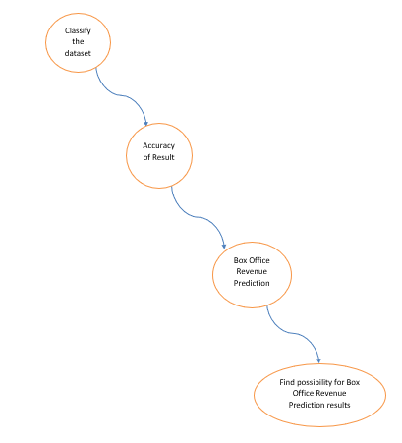

MODULES
Dataset Collection
The process begins with gathering raw data from various sources. This could include user inputs, sensor data, or publicly available datasets related to safety threats.
Pre-processing
The collected data is cleaned and organized. Pre-processing involves removing errors, handling missing values, and formatting the data so that it can be effectively used for machine learning.
Random Selection
After pre-processing, a portion of the data is randomly selected to ensure that the training and testing datasets are representative and unbiased. This step helps in building a robust machine learning model.
Trained & Testing Dataset
Finally, the selected data is divided into training and testing datasets.
Training dataset: Used to train the machine learning model.
Testing dataset: Used to evaluate the performance and accuracy of the trained model.:
Classify the Dataset

The dataset is organized into categories based on the type of safety threats or relevant features. This helps the system understand and differentiate between safe and risky situations.
Accuracy of Result

The machine learning model analyzes the classified data and produces predictions. The accuracy of these results indicates how well the system can identify potential threats.
Women Safety

Based on the model’s analysis, the system determines the safety level for women in a given situation or location.
Find Possibility for Women Safety Results

Finally, the system predicts the likelihood or possibility of safety threats and provides actionable insights to enhance women’s safety.

ALGORITHMS USED

1. LINEAR REGRESSION

Linear Regression is a supervised learning regression algorithm used to predict a continuous numerical value based on one or more input features. It assumes a linear relationship between independent variables and the dependent variable. The model finds the best-fit straight line that minimizes the difference between predicted and actual values. Linear Regression is simple, interpretable, and widely used for forecasting and trend analysis such as predicting house prices or sales.

2. LOGISTIC REGRESSION

Logistic Regression is a supervised learning classification algorithm mainly used for binary classification problems. Instead of predicting continuous values, it predicts the probability of an instance belonging to a particular class using a sigmoid (logistic) function. The output is mapped between 0 and 1 and then classified into categories. Logistic Regression is efficient, easy to implement, and commonly used in medical diagnosis, fraud detection, and spam filtering.

3. SUPPORT VECTOR MACHINE (SVM)

Support Vector Machine is a powerful supervised learning algorithm used for both classification and regression tasks. It works by finding an optimal hyperplane that best separates data points of different classes with the maximum margin. SVM can handle linear and non-linear data using kernel functions. It performs well in high-dimensional spaces and is effective when the number of features is greater than the number of samples.

4. RANDOM FOREST

Random Forest is a supervised ensemble learning algorithm that combines multiple decision trees to improve prediction accuracy and reduce overfitting. Each tree is trained on a random subset of data and features, and the final output is determined by majority voting (classification) or averaging (regression). Random Forest is robust, handles missing values well, and performs efficiently on large datasets.

5. DECISION TREE

Decision Tree is a supervised learning algorithm used for classification and regression. It represents decisions using a tree-like structure, where each internal node denotes a feature, branches represent decision rules, and leaf nodes represent outcomes. Decision Trees are easy to understand and interpret but can suffer from overfitting if not properly pruned.

6. K-NEAREST NEIGHBORS (KNN)

K-Nearest Neighbors is a supervised, instance-based learning algorithm used for classification and regression. It classifies a data point based on the majority class of its nearest neighbors in the feature space. KNN does not build an explicit model and stores all training data, making it simple but computationally expensive for large datasets. It is sensitive to feature scaling and noise.

7. XGBOOST

XGBoost (Extreme Gradient Boosting) is an advanced supervised ensemble learning algorithm based on the gradient boosting framework. It builds models sequentially, where each new model corrects the errors of previous ones. XGBoost includes regularization techniques, making it highly efficient, accurate, and less prone to overfitting. It is widely used in competitions and real-world applications due to its speed and performance.

8. ADABOOST

AdaBoost (Adaptive Boosting) is a supervised ensemble boosting algorithm that focuses on improving weak learners, usually decision stumps. It assigns higher weights to misclassified data points so that subsequent models pay more attention to difficult cases. The final prediction is a weighted combination of all learners. AdaBoost is effective for improving accuracy but can be sensitive to noisy data and outliers.

9. GRADIENT BOOSTING

Gradient Boosting is a supervised ensemble learning technique that builds models in a sequential manner, where each new model attempts to minimize the loss function by correcting the errors of previous models. It uses gradient descent optimization to improve predictions. Gradient Boosting provides high predictive accuracy and flexibility but requires careful tuning to avoid overfitting.

10.NAÏVE BAYES

Naïve Bayes is a supervised machine learning algorithm used for classification. It works by calculating the probability of a data point belonging to each class and then choosing the class with the highest probability. It is called “naïve” because it assumes that all features are independent of each other.Naïve Bayes is fast, easy to use, and works well with large datasets. It is commonly used in spam email detection, text classification, and sentiment analysis.

PYTHON OVERVIEW
Python is a high-level, interpreted, interactive and object-oriented scripting language. Python is designed to be highly readable. It uses English keywords frequently where as other languages use punctuation, and it has fewer syntactical constructions than other languages.

Python is Interpreted: Python is processed at runtime by the interpreter. You do not need to compile your program before executing it. This is similar to PERL and PHP.

Python is Interactive: You can actually sit at a Python prompt and interact with the interpreter directly to write your programs.

Python is Object-Oriented: Python supports Object-Oriented style or technique of programming that encapsulates code within objects.

Python is a Beginner's Language: Python is a great language for the beginner-level programmers and supports the development of a wide range of applications from simple text processing to WWW browsers to games.

History of Python

Python was developed by Guido van Rossum in the late eighties and early nineties at the National Research Institute for Mathematics and Computer Science in the Netherlands.

Python is derived from many other languages, including ABC, Modula-3, C, C++, Algol-68, SmallTalk, Unix shell, and other scripting languages.

Python is copyrighted. Like Perl, Python source code is now available under the GNU General Public License (GPL).

Python is now maintained by a core development team at the institute, although Guido van Rossum still holds a vital role in directing its progress.

Python Features
Python's features include:

Easy-to-learn: Python has few keywords, simple structure, and a clearly defined syntax. This allows the student to pick up the language quickly.

Easy-to-read: Python code is more clearly defined and visible to the eyes.

Easy-to-maintain: Python's source code is fairly easy-to-maintain.

A broad standard library: Python's bulk of the library is very portable and cross-platform compatible on UNIX, Windows, and Macintosh.

Interactive Mode: Python has support for an interactive mode which allows interactive testing and debugging of snippets of code.

Portable: Python can run on a wide variety of hardware platforms and has the same interface on all platforms.

Extendable: You can add low-level modules to the Python interpreter. These modules enable programmers to add to or customize their tools to be more efficient.

Databases: Python provides interfaces to all major commercial databases.

GUI Programming: Python supports GUI applications that can be created and ported to many system calls, libraries, and windows systems, such as Windows MFC, Macintosh, and the X Window system of Unix.

Scalable: Python provides a better structure and support for large programs than shell scripting.

Apart from the above-mentioned features, Python has a big list of good features, few are listed below:

- IT supports functional and structured programming methods as well as OOP.

- It can be used as a scripting language or can be compiled to byte-code for building large applications.

- It provides very high-level dynamic data types and supports dynamic type checking.

- IT supports automatic garbage collection.

- It can be easily integrated with C, C++, COM, ActiveX, CORBA, and Java.

Python is available on a wide variety of platforms including Linux and Mac OS X. Let's understand how to set up our Python environment.
python liabraries:
- Numpy
- Pandas
- matplotlib
- sklearn
- seaborn

Numpy
NumPy (short for Numerical Python ) is one of the most fundamental libraries in Python for scientific computing. It provides support for large, multi-dimensional arrays and matrices along with a collection of mathematical functions to operate on arrays.
At its core it introduces the ndarray (n-dimensional array) object which allows us to store and manipulate large datasets in a memory-efficient manner. Unlike Python's built-in lists, NumPy arrays are homogeneous and enable faster operations.
What is NumPy Used for?
With NumPy, you can perform a wide range of numerical operations, including:

Creating and manipulating arrays.
Performing element-wise and matrix operations.
Generating random numbers and statistical calculations.
Conducting linear algebra operations.
Working with Fourier transformations.
Handling missing values efficiently in datasets.
Why Learn NumPy?
NumPy speeds up math operations like addition and multiplication on large groups of numbers compared to regular Python..
It’s good for handling large lists of numbers (arrays), so you don’t have to write complicated loops.
It gives ready-to-use functions for statistics, algebra and random numbers.
Libraries like Pandas, SciPy, TensorFlow and many others are built on top of NumPy.
NumPy uses less memory and stores data more efficiently, which matters when working with lots of data.
Pandas
Pandas is open-source Python library which is used for data manipulation and analysis. It consist of data structures and functions to perform efficient operations on data. It is well-suited for working with tabular data such as spreadsheets or SQL tables. It is used in data science because it works well with other important libraries. It is built on top of the NumPy library
ANACONDA NAVIGATOR
Anaconda Navigator is a desktop graphical user interface (GUI) included in Anaconda distribution that allows you to launch applications and easily manage conda packages, environments and channels without using command-line commands. Navigator can search for packages on Anaconda Cloud or in a local Anaconda Repository. It is available for Windows, mac OS and Linux.

Why use Navigator?
In order to run, many scientific packages depend on specific versions of other packages. Data scientists often use multiple versions of many packages, and use multiple environments to separate these different versions.
The command line program conda is both a package manager and an environment manager, to help data scientists ensure that each version of each package has all the dependencies it requires and works correctly.
Navigator is an easy, point-and-click way to work with packages and environments without needing to type conda commands in a terminal window. You can use it to find the packages you want, install them in an environment, run the packages and update them, all inside Navigator.
- Data Cleaning, Merging and Joining: Clean and combine data from multiple sources, handling inconsistencies and duplicates.
- Handling Missing Data: Manage missing values (NaN) in both floating and non-floating point data.
- Column Insertion and Deletion: Easily add, remove or modify columns in a DataFrame.
- Group By Operations: Use "split-apply-combine" to group and analyze data.
- Data Visualization: Create visualizations with Matplotlib and Seaborn, integrated with Pandas.

Pandas Series
A Pandas Series is one-dimensional labeled array capable of holding data of any type (integer, string, float, Python objects etc.). The axis labels are collectively called indexes.

Pandas Series is created by loading the datasets from existing storage which can be a SQL database, a CSV file or an Excel file. It can be created from lists, dictionaries, scalar values, etc.
Pandas DataFrame
Pandas DataFrame is a two-dimensional data structure with labeled axes (rows and columns). It is created by loading the datasets from existing storage which can be a SQL database, a CSV file or an Excel file. It can be created from lists, dictionaries, a list of dictionaries etc.
Matplotlib
Matplotlib is an open-source visualization library for the Python programming language, widely used for creating static, animated and interactive plots. It provides an object-oriented API for embedding plots into applications using general-purpose GUI toolkits like Tkinter, Qt, GTK and wxPython. It offers a variety of plotting functionalities, including line plots, bar charts, histograms, scatter plots and 3D visualizations. Created by John D. Hunter in 2003, Matplotlib has become a fundamental tool for data visualization in Python, extensively used by data scientists, researchers and engineers worldwide.
important Facts to know:
Matplotlib Pyplot: The pyplot module is a collection of functions that make Matplotlib work like MATLAB, providing a simple interface for creating plots.
Figure and Axes: In Matplotlib, figures represent the overall container, while axes refer to the individual plots within a figure.
Integration with Pandas: Matplotlib works seamlessly with Pandas DataFrames, enabling efficient data visualization.
Toolkits in Matplotlib
Several toolkits extend Matplotlib's functionality, some of which are external downloads, while others are included with Matplotlib but have external dependencies. Here are some of the most notable toolkits:

Seaborn: A high-level statistical data visualization library built on top of Matplotlib, extremely popular for creating attractive and informative statistical graphics with minimal code.
Mplot3d: Integrated into Matplotlib itself, this toolkit is the go‑to choice for creating 3‑D plots with ease and flexibility.
GeoPandas: A library that leverages Matplotlib for geospatial plotting, simplifying the handling of geospatial data without needing a spatial database.
Cartopy: A modern mapping library offering an object‑oriented approach to map projections and geospatial data, largely replacing Basemap in new projects.
Tikzplotlib: A niche toolkit that converts Matplotlib figures into LaTeX-friendly TikZ/PGFPlots code, ideal for producing high-quality, publication-ready plots.
Seaborn
What is Seaborn
Seaborn is an amazing visualization library for statistical graphics plotting in Python. It provides beautiful default styles and color palettes to make statistical plots more attractive. It is built on top matplotlib library and is also closely integrated with the data structures from pandas.
Seaborn aims to make visualization the central part of exploring and understanding data. It provides dataset-oriented APIs so that we can switch between different visual representations for the same variables for a better understanding of the dataset.

Different categories of plot in Seaborn
Plots are basically used for visualizing the relationship between variables. Those variables can be either completely numerical or a category like a group, class, or division. Seaborn divides the plot into the below categories -

Relational plots: This plot is used to understand the relation between two variables.
Categorical plots: This plot deals with categorical variables and how they can be visualized.
Distribution plots: This plot is used for examining univariate and bivariate distributions
Regression plots: The regression plots in Seaborn are primarily intended to add a visual guide that helps to emphasize patterns in a dataset during exploratory data analyses.
Matrix plots: A matrix plot is an array of scatterplots.
Multi-plot grids: It is a useful approach to draw multiple instances of the same plot on different subsets of the dataset.

WHAT APPLICATIONS CAN I ACCESS USING NAVIGATOR?
The following applications are available by default in Navigator:
- Jupyter Lab
- Jupyter Notebook
- QT Console
- Spyder
- VS Code
- Glue viz
- Orange 3 App
- Rodeo
- RStudio
Advanced conda users can also build your own Navigator applications

How can I run code with Navigator?
The simplest way is with Spyder. From the Navigator Home tab, click Spyder, and write and execute your code.
You can also use Jupyter Notebooks the same way. Jupyter Notebooks are an increasingly popular system that combine your code, descriptive text, output, images and interactive interfaces into a single notebook file that is edited, viewed and used in a web browser.

What’s new in 1.9?
- Add support for Offline Mode for all environment related actions.
- Add support for custom configuration of main windows links.
- Numerous bug fixes and performance enhancements.
Sklearn
Building machine learning models from scratch can be complex and time-consuming. Scikit-learn which is an open-source Python library which helps in making machine learning more accessible. It provides a straightforward, consistent interface for a variety of tasks like classification, regression, clustering, data preprocessing and model evaluation. Whether we're new to machine learning or have some experience it makes easy to build reliable models quickly. In this article, we’ll see important features and steps to get started with Scikit-learn.
Features of Scikit-learn
Scikit-learn is used because it makes building machine learning models straightforward and efficient. Here are some important reasons:
Ready-to-Use Tools: It provides built-in functions for common tasks like data preprocessing, training models and making predictions. This saves time by avoiding the need to code algorithms from scratch.
Easy Model Evaluation: With tools like cross-validation and performance metrics it helps to measure how well our model works and identify areas for improvement.
Wide Algorithm Support: It offers many popular machine learning algorithms including classification, regression and clustering which gives us flexibility to choose the right model for our problem.
Smooth Integration: Built on top of important Python libraries like NumPy and SciPy so it fits into our existing data analysis workflow.
Simple and Consistent Interface: The same straightforward syntax works across different models helps in making it easier to learn and switch between algorithms.
Model Tuning Made Easy: Tools like grid search help us fine-tune our model’s settings to improve accuracy without extra hassle.
Benefits Of Using Scikit-Learn
User-Friendly: Scikit-learn’s consistent and simple interface makes it accessible for beginners and best for experts.
Time-Saving: Pre-built tools and algorithms reduce development time which allows us to focus more on solving problems than coding details.
Better Model Performance: Easy-to-use tuning and evaluation tools helps in improving model accuracy and reliability.
Flexible and Scalable: Supports a wide range of algorithms and integrates smoothly with other Python libraries helps in making it suitable for projects of any size.
Strong Community Support: A large, active community ensures regular updates, extensive documentation and plenty of resources to help when we get stuck.
With its accessible tools and reliable performance, Scikit-learn makes machine learning practical and achievable for everyone.
SYSTEM TESTING
TESTING METHODS
Functional Testing
Functional tests provide systematic demonstrations that functions tested are available as specified by the business and technical requirements, system documentation, and user manuals.
Functional testing is centered on the following items:
- Functions: Identified functions must be exercised.
- Output: Identified classes of software outputs must be exercised.
- Systems/Procedures: system should work properly

Integration Testing

Software integration testing is the incremental integration testing of two or more integrated software components on a single platform to produce failures caused by interface defects.

Test Case for Excel Sheet Verification:

Here in machine learning we are dealing with dataset which is in excel sheet format so if any test case we need means we need to check excel file. Later on classification will work on the respective columns of dataset .

Test Case 1 :

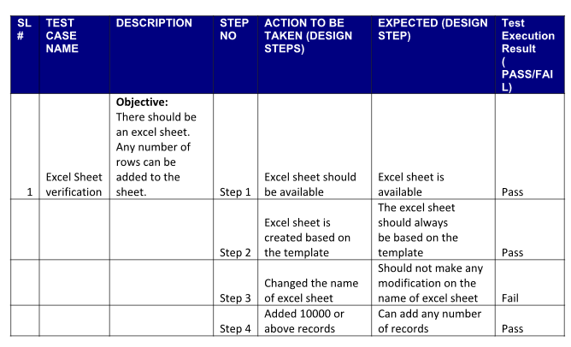

RESULTS AND ANALYSIS
Experimental evaluation shows that ensemble and deep learning models significantly outperform traditional regression techniques. Models such as XGBoost and Random Forest achieve lower prediction error and higher R² scores, indicating better fit and generalization. Feature importance analysis reveals that budget, genre, release timing, and cast popularity play a major role in revenue prediction. The results confirm that advanced machine learning models provide a reliable and efficient solution for box office revenue forecasting.

CONCLUSION

This project demonstrates that advanced machine learning techniques can effectively predict box office revenue with higher accuracy than conventional methods. By utilizing diverse features and powerful learning algorithms, the proposed system reduces financial uncertainty and supports better decision-making in the film industry. The results validate the potential of data-driven approaches for commercial success prediction in entertainment analytics.

FUTURE SCOPE

Future work can incorporate real-time social media sentiment analysis, trailer view statistics, and streaming platform data to further enhance prediction accuracy. The system can be extended to predict regional revenues, opening weekend performance, and long-term profitability. Integration with deep learning models such as transformers and automated machine learning (AutoML) frameworks can further improve scalability and performance.

REFERENCES
S. Asur and B. A. Huberman, “Predicting the future with social media,” IEEE/WIC/ACM Int. Conf. Web Intelligence, 2010.

R. Sharda and D. Delen, “Predicting box-office success of motion pictures,” Expert Systems with Applications, 2006.

J. Eliashberg et al., “Demand-driven scheduling of movies,” Marketing Science, 2000.

Y. Zhang and S. Skiena, “Improving movie gross prediction through social media analysis,” IEEE Int. Conf. Data Mining, 2010.

W. Du, Z. Xu, and Y. Huang, “Movie box office prediction using machine learning,” IEEE Access, 2019.

L. Yu et al., “Box office revenue forecasting using ensemble learning,” IEEE Int. Conf. Big Data, 2018.

A. Ahmed and M. Afzal, “A hybrid ML approach for movie revenue prediction,” IEEE Access, 2020.

C. Joshi et al., “Deep learning for movie performance prediction,” IEEE Int. Conf. Neural Networks, 2019.

H. Wang and Y. Wang, “Feature-based prediction of box office revenue,” IEEE Int. Conf. Data Science, 2017.

S. Mishra and P. K. Dash, “Predictive analytics for film success,” IEEE Int. Conf. Computing, 2018.

M. T. Ribeiro et al., “Why should I trust you? Explaining predictions,” IEEE Trans. Knowledge and Data Engineering, 2016.

T. Chen and C. Guestrin, “XGBoost: A scalable tree boosting system,” IEEE Int. Conf. KDD, 2016.

L. Breiman, “Random forests,” IEEE Trans. Pattern Analysis and Machine Intelligence, 2001.

Y. LeCun et al., “Deep learning,” IEEE Signal Processing Magazine, 2015.

J. Friedman, “Greedy function approximation: A gradient boosting machine,” IEEE Annals of Statistics, 2001.

